**DAILY ONLINE ACTIVITIES SUMMARY**

|  |  |  |  |  |  |  |  |  |
| --- | --- | --- | --- | --- | --- | --- | --- | --- |
| **Date:** | **10-7-2020** | | | | | **Name:** | **Prajna** | |
| **Sem & Sec** | **8th sem ‘B’** | | | | | **USN:** | **4AL16CS067** | |
| **Online Test Summary** | | | | | | | | |
| **Subject** | | **-** | | | | | | |
| **Max. Marks** | | **-** | | **Score** | | | **-** | |
| **Certification Course Summary** | | | | | | | | |
| **Course** | **Introduction to CSS** | | | | | | | |
| **Certificate Provider** | | | **Great learning** | | **Duration** | | | **5hrs** |
| **Coding Challenges** | | | | | | | | |
| **Problem Statement:**1**.** Write a c program to sort array elements in descending order. | | | | | | | | |
| **Status: Completed** | | | | | | | | |
| **Uploaded the report in GitHub**  **GitHub link:** | | | | | **Yes**  **https://github.com/alvas-education-foundation/prajna_k** | | | |
| **If yes Repository name** | | | | | **prajna_k** | | | |
| **Uploaded the report in slack** | | | | | **yes** | | | |

Online Test Details: (Attach the snapshot and briefly write the report for the same)

Certification Course Details: (Attach the snapshot and briefly write the report for the same)

Coding Challenges Details: (Attach the snapshot and briefly write the report for the same)

2) certification course

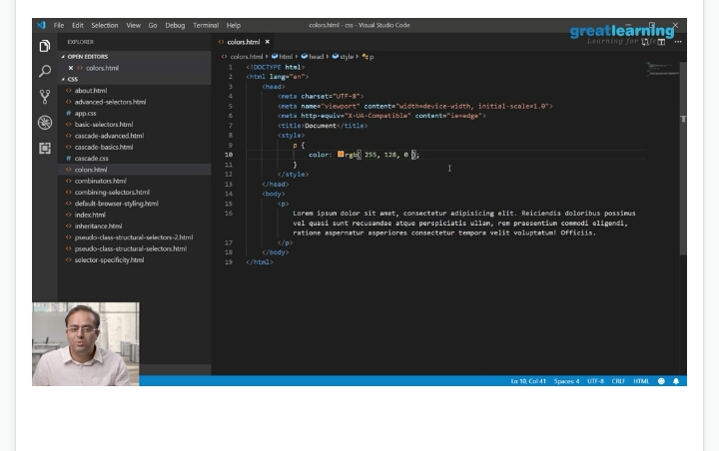

3) coding challenges

|  |
| --- |
|  |
|  |  |
|  |  |
|  |  |
|  |  |
|  |  |

#include <stdio.h>

void main()

{

int arr1[100];

int n, i, j, tmp;

printf("\n\nsort elements of array in descending order :\n");

printf("----------------------------------------------\n");

printf("Input the size of array : ");

scanf("%d", &n);

printf("Input %d elements in the array :\n",n);

for(i=0;i<n;i++)

{

printf("element - %d : ",i);

scanf("%d",&arr1[i]);

}

for(i=0; i<n; i++)

{

for(j=i+1; j<n; j++)

{

if(arr1[i] < arr1[j])

{

tmp = arr1[i];

arr1[i] = arr1[j];

arr1[j] = tmp;

}

}

}

printf("\nElements of array is sorted in descending order:\n");

for(i=0; i<n; i++)

{

printf("%d ", arr1[i]);

}

printf("\n\n");

}